SEE SECOND PAGE FOR FILE SETUP!!!
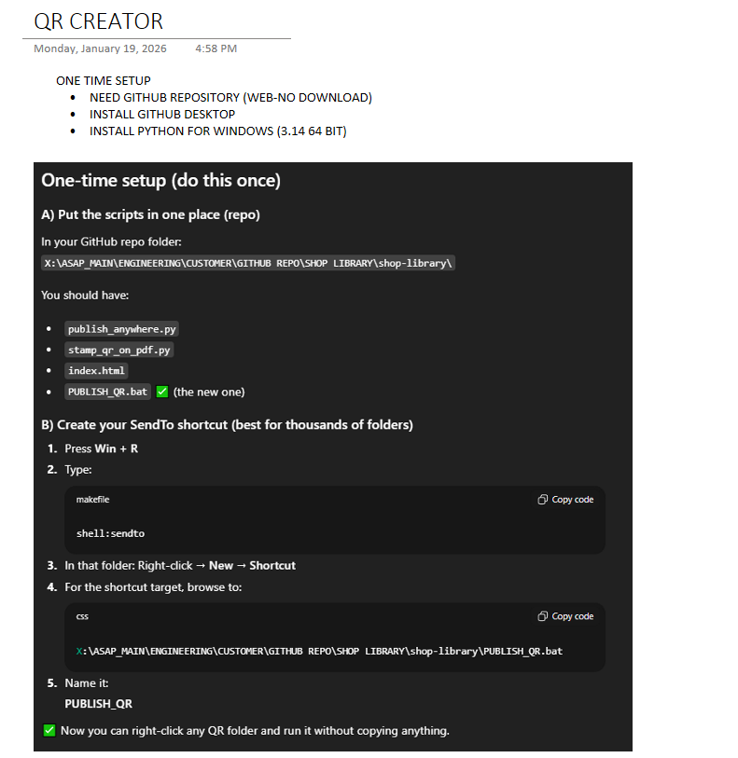
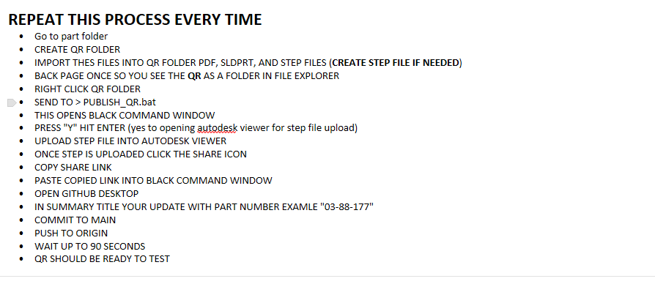
FILE SET UP
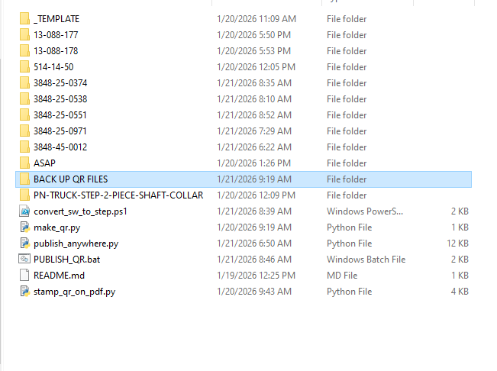
- Index file should be saved in the _TEMPLATE folder
- Save the PUBLISH_QR.bat file to the sendto page
- Copy Publish_QR.bat file
- WIN + R
- SENDTO ENTER
- IN THE SENDTO FOLDER
- Paste PUBLISH_QR.bat file here
- READY TO USE!

